Cloud Architect, Cloud Network Engineer, Cloud Administrator

Compute, Networking

**Lab Steps**

Task 1: Sign in to AWS Management Console

1. Click on the  button, and you will get redirected to AWS Console in a new browser tab.
2. On the AWS sign-in page,

* Leave the Account ID as default. Never edit/remove the 12 digit Account ID present in the AWS Console. otherwise, you cannot proceed with the lab.
* Now copy your **User Name** and **Password** in the Lab Console to the **IAM Username and Password** in AWS Console and click on the **Sign in** button

     3. Once Signed In to the AWS Management Console, Make the default AWS Region as **US East (N. Virginia) us-east-1.**

4.  Select Maybe later in New AWS Console Home page pop-up.

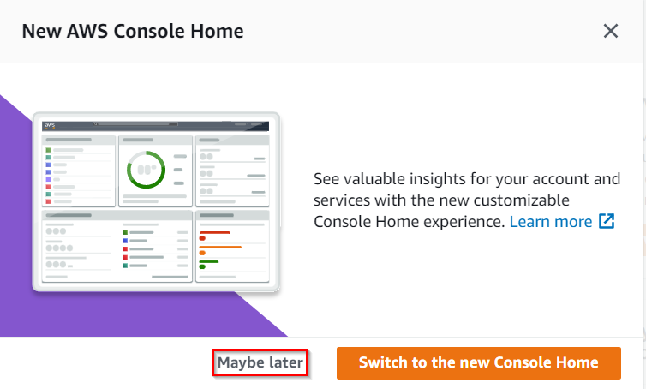

Task 2: Create a CloudWatch Log

1. Navigate to the **Services** menu at the top and choose **CloudWatch**under **Management and Governance**.
2. Click on **Log Groups** under **Logs**in the left-side panel, click on 
3. Enter the Log Group Name : ***whizvpclogs***and click on **Create**button.

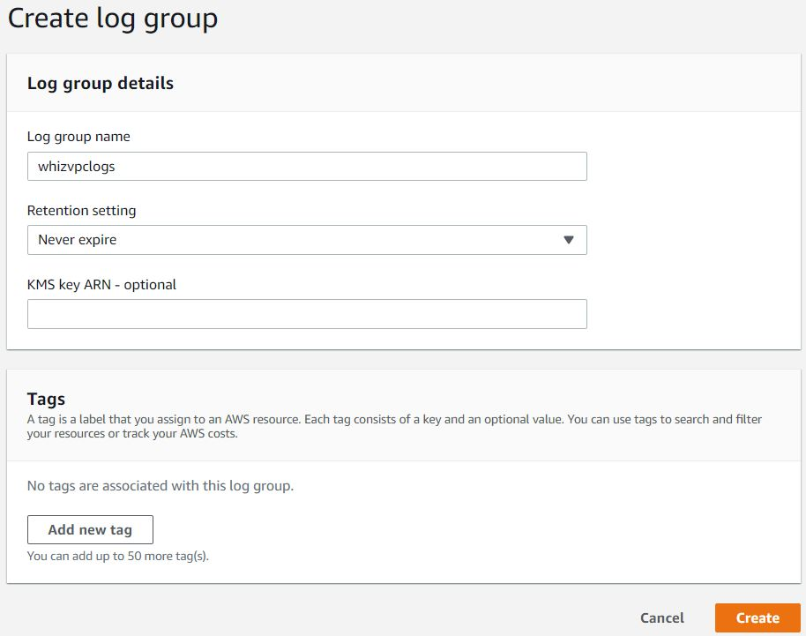

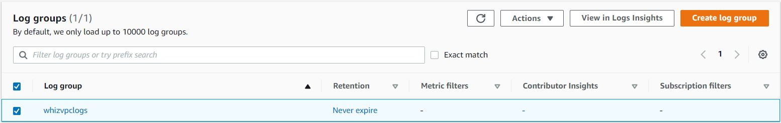

Task 3: Create a VPC

1. Navigate to the **Services** menu on the top and choose **VPC** under  **Networking and Content Delivery**.
2. Click on **Your VPC’s** in the left side panel then click on **Create VPC.**
3. Select **VPC only.**
4. Enter the Name tag: ***whizvpc***and enter IPv4 CIDR block: ***10.1.0.0/16***. Leave other options as default and click on **Create**button.

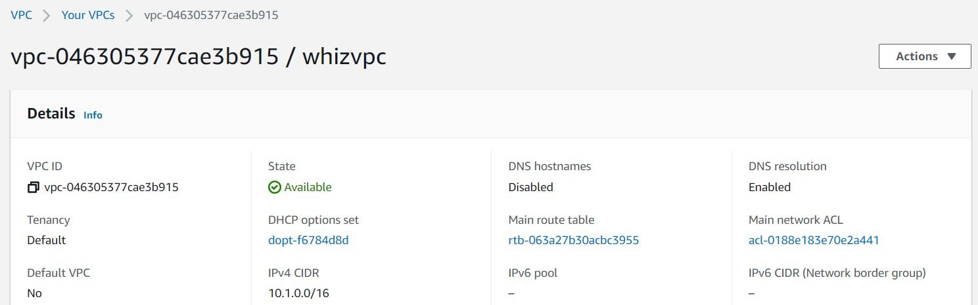

Task 4: Create VPC Flow Logs

1. Inside **whizvpc,**scroll down and click on **Flow logs**taband click on **Create Flow Log**button**.**
2. Under Flow log settings: Name: ***whizflow***
3. Select “Filter” as **Accept**and select “Destination” as **Send to CloudWatch Logs.** Choose the above created CloudWatch Logs “**whizvpclogs**”.
4. Choose the IAM role “**EC2Role_<RANDOM_NUMBER>**” and leave the others as default. Click on **Create flow log.**

Once the flow logs are created, scroll down click on **Flow Logs.**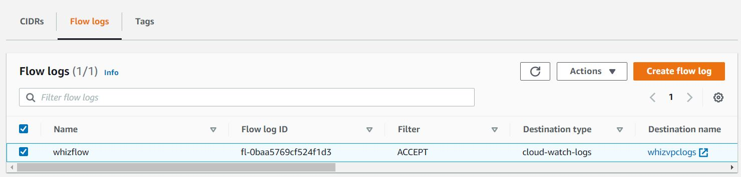

1. Now you have successfully learned how to create VPC Flow Logs.

**Completion and Conclusion**

1. You have successfully created the CloudWatch Logs.
2. You have successfully created the VPC.
3. You have successfully created the VPC Flow Logs.

**End Lab**

1. Sign out of AWS Account.
2. You have successfully completed the lab.
3. Once you have completed the steps click on  from your whizlabs dashboard.

0h 44m 13s left

End Lab[Open Console](https://334544782246.signin.aws.amazon.com/console?region=us-east-1)

Lab Credentials

User Name



Password



Access Key



Secret Key



Support Documents

Need help?

* [How to use Hands on Lab](https://business.whizlabs.com/labs/support-document/labs-instructions-and-guidelines)
* [Troubleshooting Lab](https://business.whizlabs.com/labs/support-document/lab-troubleshooting-need-help)
* [FAQs](https://business.whizlabs.com/labs/faqs-labs-general)

Submit Feedback

Share

* [About Us](https://www.whizlabs.com/about-us/)
* [Instructions and Guidelines](https://business.whizlabs.com/labs/instructions-and-guidelines)
* [FAQ’s](https://business.whizlabs.com/labs/faqs-labs-general)
* [Contact Us](https://www.whizlabs.com/contact-us/)

[](https://business.whizlabs.com/labs/)© 2023, Whizlabs Education INC.